CHAPTER 6: The Earth in space
Worksheet 6.4

Astronomical history
Science Quest 7: pages 226–228
Student: Class:

Dreamtime story
1. Complete the sentences:
The Warlpiri Aboriginal people explained a ……………… eclipse as the result of the moon-man being threatened by the sun-woman who is pursuing him and catching up. The solar and lunar eclipse dreamtime stories demonstrate that aboriginal people had an understanding that eclipses were caused by a ……………… between the sun and the moon.

Ptolemy
2. Claudius Ptolemy (AD 85–165) developed a model of the universe.
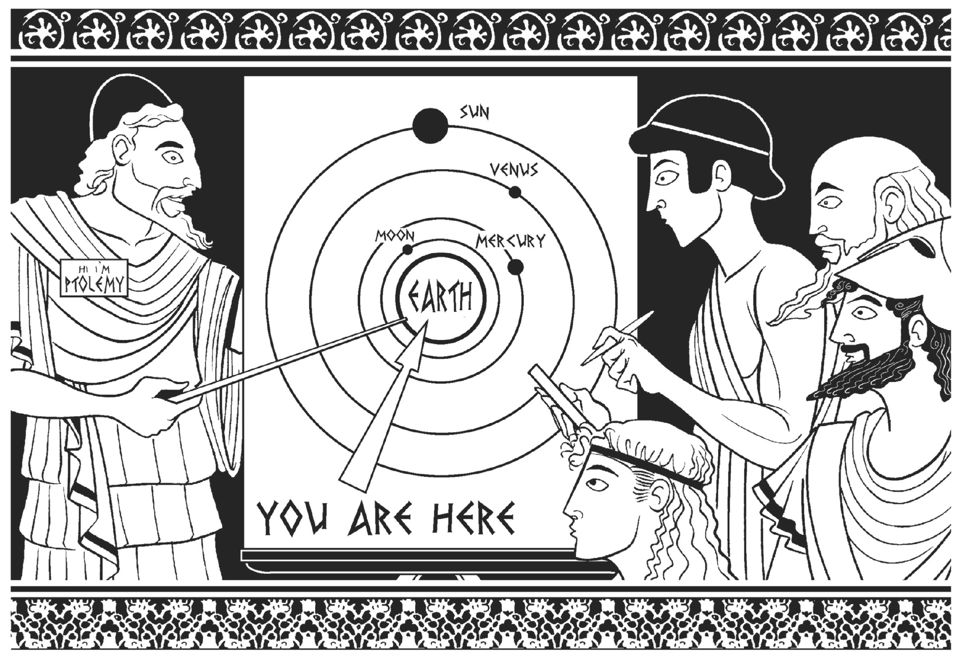
(a) Use the diagram to describe Ptolemy’s model of the universe.

(b) Where did Ptolemy place the stars in his model?

(c) Ptolemy knew that Mars moved across the sky in a looping motion called retrograde motion. His model explained this motion using epicycles. Use the diagram below left to explain the idea of epicycles; label the diagram below right where necessary.

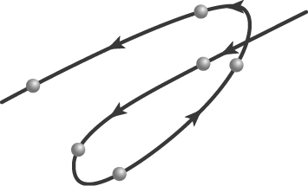  Retrograde motion | 